All Japan Championships 2005

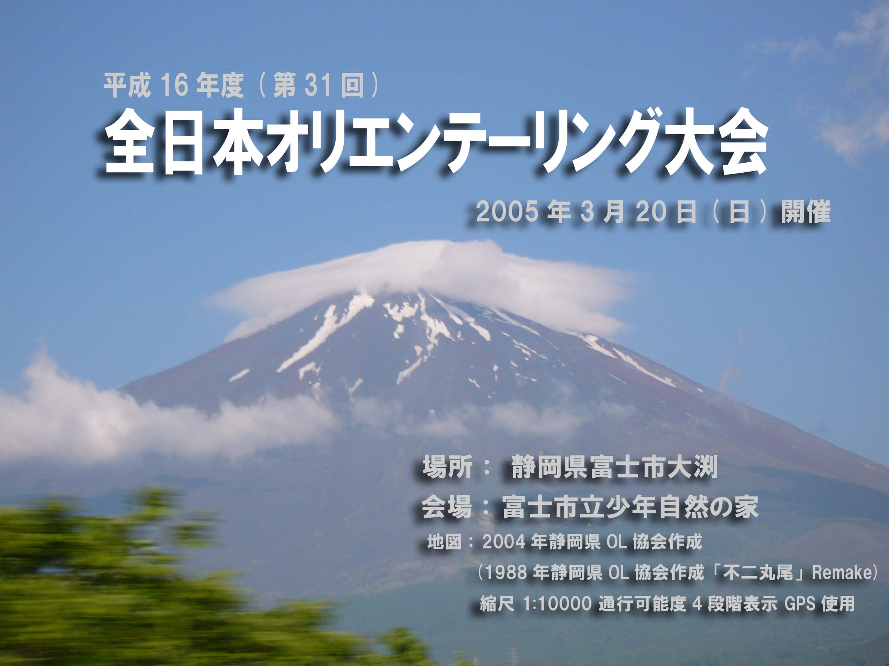

Date: March 20th 2005 (Sun)
Assembly area: Fuji-city Shonen shizen no Ie (youth outdoor centre)
10847‐1 Obuchi, Fuji-city, Shizuoka

Map: 2004 Shizuoka orienteering association
(1998 Shizuoka orienteering association ‘Fuji Marubi’ remade)
1:10000 5 colors with GPS

Organizer: Japan Orienteering Association
Shizuoka Orienteering Association
Technical Director: Rob PLOWRIGHT
Course planner: Rob PLOWRIGHT

Controller: WAKAUME Tomoyuki

Web: http://www.orienteering.com/~joc2004/index.html
Classes

Class | Age | Winning  Time(min.) | Class | Age | Winning  Time(min.)
M21E | restricted | 90 | W21E | restricted | 75
M20E | restricted | 80 | W20E | restricted | 60
M70A | 70- | 50
M65A | 65- | 60 | W65A | 65- | 40
M60A | 60- | 50 | W60A | 60- | 40
M55A | 55 - | 50 | W55A | 55- | 45
M50A | 50- | 55 | W50A | 50- | 45
M45A | 45- | 60 | W45A | 45- | 45
M40A | 40- | 65 | W40A | 40- | 50
M35A | 35- | 70 | W35A | 35- | 55
M21A | 21- | 80 | W21A | 21- | 65
M21AS | 21- | 60 | W21AS | 21- | 50
M20A | 17-20 | 70 | W20A | 17-20 | 60
M18A | 15-18 | 60 | W18A | 15-18 | 50
M16A | 13-16 | 50 | W16A | 13-16 | 40
M14 | 11-14 | 50 | W14 | 11-14 | 40
M12 | 11-12 | 45 | W12 | 11-12 | 40
M10 | -10 | 40 | W10 | -10 | 40
MBL | All | 50 | WBL | All | 45
MBM | All | 50 | WBS | All | 45
MBS | All | 50
MN | 15- | 40 | WN | 15- | 40
E： Elite; Have to be qualified
A： For very experienced orienteers
B： For experienced orienteers
Ｌ=Long, Ｍ=Middle, Ｓ=Short
N： Beginners
- You cannot enter the above classes on the event day. However, it is possible to enter the following classes on the event day; ＯＡＬ, ＯＡＭ, ＯＡＳ, ＯＢ, ＯＮ
(People who enter on the event day won’t be allowed to use their own E cards. Please rent it. )

・No prizes will be given for the people who didn’t enter in advance.
・The age is the age at March 31st 2005.
・Classes may be divided if too many people are entered in one class.
・Classes may be combined if they have too few entries.
・The winning time may be changed.
・There will be seeding in Ｍ２１Ｅ and Ｗ２１Ｅ class.

*There is a group class for the beginners as well. Please contact if you are interested.

【Elite class qualification】
Entry to elite classes is restricted to qualified entrants. Please write your best result in last 1year or the current world ranking in the application form., and Japan Orienteering Association will approve your qualification according to your result.
【Entry Fees】
Classes | Entry Fee
Elite | \4,500 | ・No printed program  －\200  ・No E-card rent  －\300  (Up to \500 discount)
A Class | \4,000
B Class  A Class (Under 18 years old) | \3,000
B Class (Under 18 years old) | \2,500
N class | \2,000
※ Entry fees will not be refunded for any reason.

- There is a \200 discount for people who use their ownＥ-ｃａｒｄｓ: please write your E-card number in the space provided on the entry form. There is also a \300 discount for people who don’t require a printed program. Please note in the application form if you need a printed program. The program will be available on our event web site later.
http://www.orienteering.com/~joc2004/index.html

【Payment】
Please pay the entry fee (cash only- Japanese Yen) on the event day at the reception desk.

Entry Form
Please e-mail or fax the entry form to Ms Hisako Murakoshi..
E-mail： joc2004shizuoka@s9.dion.ne.jp
Ｆａｘ： +91 543-34-9754

■Dead line February 4th 2005（Fri）

- Inquiries
Should be directed to: Ms Masumi TOMITA
E-mail： masumi@tokai.or.jp
Ｆａｘ： +91 55-973-7021

- Access/Transportations
【Event Centre】 Fuji-city Shonen Shizen no Ie (youth outdoor centre)
10847-1 Obuchi, Fuji-city, Shizuoka
【Registration open】 8:30～10:30

【Public Transport】
Trains:
The event centre can be reached by public transport. Either take a local train to FUJI station on the JR (Japan Rail) Tokaido Line or by taking a Shinkansen (Bullet Train) to SHIN FUJI station on the JR Tokaido Shinkansen line. For information on train time tables please contact masumi@tokai.or.jp
Local Buses
From Fuji Station : Get off at ‘Fuji’ station on the Tokaido line. Take the Fujikyu Shizuoka bus bound for‘NihonLand’leaving at 9:00 from the north exit. Get off at ‘Marubi Shizen Koen Iriguchi’. It will take about 30min. It’s about 15 minutes walk to the assembly area from ‘Marubi Shizen Koen Iriguchi’ bus stop.
From Shin Fuji Station : Get off at “Shin Fuji” station. Take the Fujikyu Shizuoka bus bound for ‘Yoshiwara Chuo stn’ It’s about 13 minutes to get to the station to change the bus. Get off at the Yoshiwara Chuo station and take the bus to ‘Nihon land’ leaving at 9:20. Get off at ‘Marubi Shizen Koen Iriguchi’. It will take about 30min. It’s about 15 minutes walk to the assembly area from ‘Marubi Shizen Koen Iriguchi’ bus stop.
Event Bus
As there is only one local bus service a day from Fuji and Shin Fuji station to the assembly area we will offer the following special buses
（Fuji station 8:00・Shin Fuji station 7:40,8:15 ～ Assembly area）

A special bus from Tokyo will also be available.

Please contact the travel agent Nihon Ryoko Tokyo Minami branch (person in charge; Kobayashi, Takamiya) Tel : +91 3- 3567-5973
E-mail: tokyominami_net@nta.co.jp

【By Car】
50 min. drive from Tomei Expressway Fuji Interchange. Take Route72 and 469 to Mt Fuji Children’s World.
50 min. drive from Tomei Expressway Susono Interchange. Take Route469 to Mt Fuji Children’s World.
90 min. drive from Chuo Expressway Kawaguchiko Interchange. Take Route 139 and 469 to Mt Fuji Children’s World..
Parking Information
All parking for the Japan Championships will be Mt. Fuji Children’s World. There will be a shuttle bus to the assembly area. It will take about 20 min. from Mt.Fuji Children’s World to the assembly area. （\500円 return.. Please pay at the parking.）
If you want to park, please note on the application form.
We will allocate the cars in case there are too many participants.
NOTE: There are some parking areas close to the assembly area, but they are reserved for use by the general public. Japan Championships competitors may not use them. There will be a drop off zone close to the event centre where people and luggage can be off loaded before proceeding to the parking at Mt Fuji Children’s World.

Technical information
【First Starts】 9.30am
【Type】 Long distance
【Rules】 Japan Orienteering Association’s Competition Rules.
【Control descriptions】 ＩＯＦ symbols （Japanese will be used forＮclasses）

【Terrain description】
The competition terrain lies on the southern slopes of Mt Fuji between 500 and 650m. It is predominantly open cedar forest with a moderately dense network of roads, forestry tracks, and walking paths. Some parts of the terrain have extensive areas of reduced runnability. Contour detail varies from moderate to very detailed and parts of the terrain are crisscrossed by complex networks of watercourses (usually dry) and occasional steep sided ravines. The terrain is also traversed by a lava flow from the last eruption of Mt Fuji (1707). These areas are extremely rocky underfoot and covered in dense deciduous forest.

【Punching】 Emit
【Ruled time】 Elite class ：150％ of the winning time Ａ class： 200％ of the winning time
【Training map】 We will offer the map ‘Sekotsuji（勢子辻）’ for training on19th. It’s about 15 minutes drive from the event area.

3 Days of Orienteering
The championships form part of three days of orienteering. The following events are also being held:
March 19th（Sat）: Park Orienteering at Mt. Fuji Children’s World (map scale 1:5000)
March 21st（Mon）: Sprint Relay (map scale 1:5000) using the event centre as the Japan Championships.
For more information on these events please contact: masumi@tokai.or.jp

【Embargoed Areas】
The areas of these previous maps are embargoed: ’Sakasasugi 逆杉’, ’Fuji 富士’, and ’Fuji Marubi 富士丸火’

Note
1 Start times will be allocated by the organizers.
2 The program will only be sent to the people who requested it. If you have not received it by about 7 days before the event please contact us.
3 No proxy running will be permitted.
4 Smoking is not allowed at the event centre.
5 Vendors wishing to sell goods at the event centre must apply to Shizuoka Orienteering Association 1 month before the event.
6 No tents may be pitched at the event centre. Shelter and change rooms are available.

----------------------------------------------------------------------------------------------------

ALL JAPAN CHAMPIONSHIPS APPLICATION FORM

Name:.......................................................................................... Sex: M/F
Address: ............................................................................................................
.......................................................... ......................................................................
Birthday: Y/M/D ............................................................ Age: ..................
Country: ..............................................Club:.......................................................
Class: ................................. Entry fee : \...........................................
E card: rent / my E card number （EMIT）is .............................................
Program: not required / please mail to above address
Parking lot: not required / need to park
Result of the last 1 year in orienteering:
...................................................................................................................................
Current World Ranking： ..............................

